

Groupwork 1

Mental Health Survey Data Analysis

Team 3 | CSC 465 | 02/26/2017

# Question 1

## Minutes of the discussion

* Talked about what kind of data we have and how to break it up.
* We split into 2 subgroups – one to work on geographical data and the other on non-geographical data
* We broke up between differences in mental and physical health and geography
* We each will do 2 graphs for our assignment 3 based on our subgroups and then we can choose from the 8 graphs we have to decide what to submit
* We have more data from US than other countries so how do we fix this? A possibility is to put all other countries in one group
* Let’s look up the terms in part c and see what we all come up with (our discussion is listed below)

## Group liaison

Deepak will be the group’s liaison.

## Cursory Analysis

* We have done basic exploratory visualizations like univariate scatterplots, bar graphs to show difference in gender, contingency plots to show differences between people’s perception of physical vs. mental health in the workplace, and box plots to show differences between age and gender for treatment and seeking help.
* We have made “drafts” of heatmaps to show how easy it is for someone to take leave depending on how they thought their employer viewed physical and mental health. We also made a heatmap of how easily people thought they could talk to their coworkers vs. supervisors about mental health issues. We contemplated doing a rose plot on US vs other countries with all the categories.
* We decided that we are going to do geospatial graphs since we have the state they are listed in and the countries that they live in if they are outside the US. We would do choropleth maps to show how responses differed within the US ex: treatment, getting care, family history, etc. There’s not a lot of data from other countries compared to the US so we decided we wanted to group all the other countries together as “other” and compare that category to the numbers in the US using box plots and bar graphs.
* We decided that network and cluster visualizations weren’t good for our data since we don’t have that many categories within each variable.
* We decided volumetric visualizations weren’t the best idea because it looks messy and would be hard to read with the data that we have. Volumetric data is better to show differences in land geography like mountains or an ocean.

## Past Visualizations

We decided to split our group in geography data, and seeing the difference between physical and mental health perception in the workplace within the people that participated in the survey. When we looked online most of the data was on attitudes towards mental health. The CDC did a [whole report](https://www.cdc.gov/hrqol/Mental_Health_Reports/pdf/BRFSS_Full%20Report.pdf) on it and used bar graphs to show the differences in age, gender, and race. Looking at other links they also used pie charts to show the percentage of different categories and maps to show distribution across states.

# Question 2

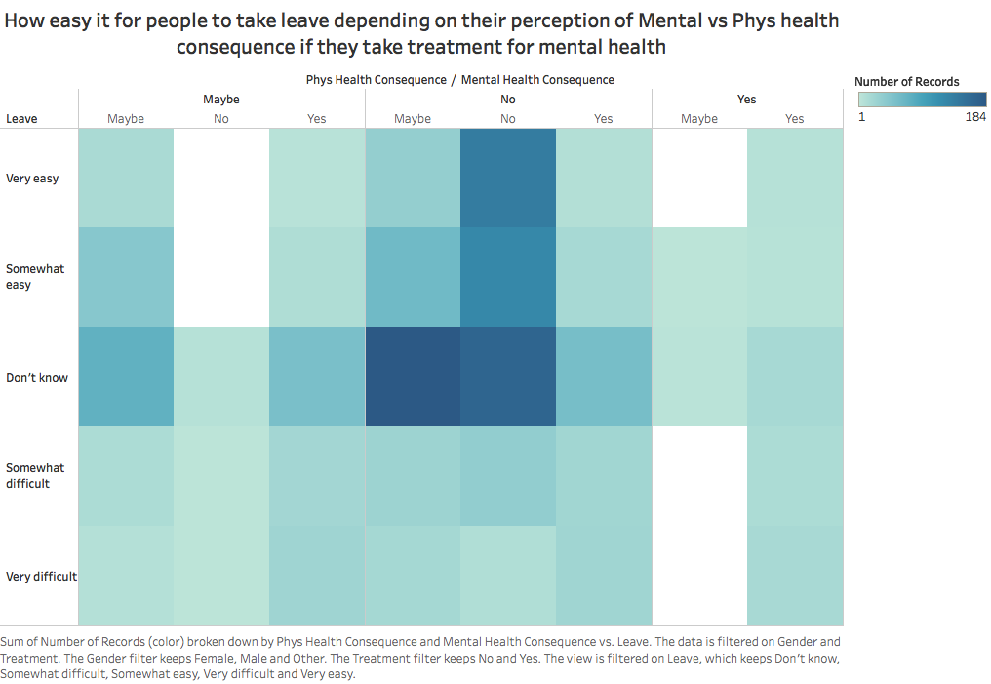

We made a heat map using Tableau to show if respondents who take treatment for mental illness thought they could leave work because of a mental health issue depending on if they thought there would be a consequence for discussing mental health and/or physical health with their employee. We had color show the number of responses.

The heat map shows that the majority of people who did not know if they could take leave did not think there was physical health consequence, and either said no or maybe to a mental health consequence.

People who said it would be very easy to take leave, most answered no to both physical and mental health consequence. Few people said that it would be very difficult to taking leave. Not many people answered saying there would be a physical consequence but if they did answer that, most people said there would be a mental health consequence and 0 people answered then said there wouldn’t be a mental health consequence.

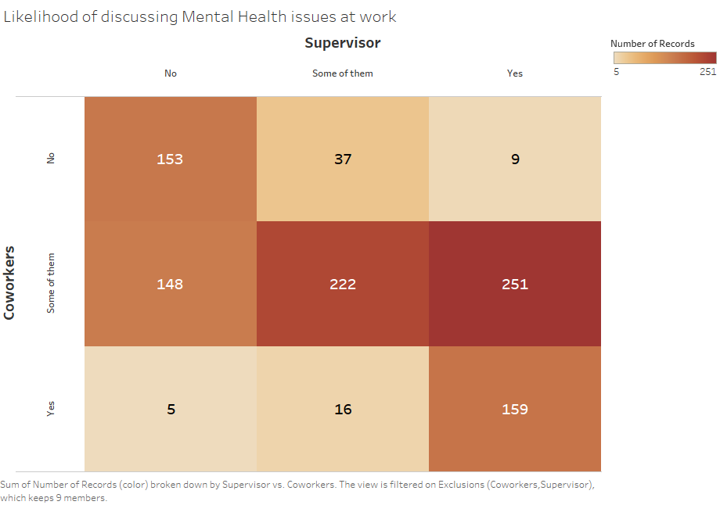

We created a heatmap using Tableau to show how likely employees are willing to discuss a mental health issue with their co-workers or supervisors.

The graph shows that most respondents who discussed mental health issues with their supervisors, would discuss the same with some of their co-workers. Respondents who discuss about mental health issues with their supervisors and do not discuss the same with their co-workers, and vice-versa, were very rare.

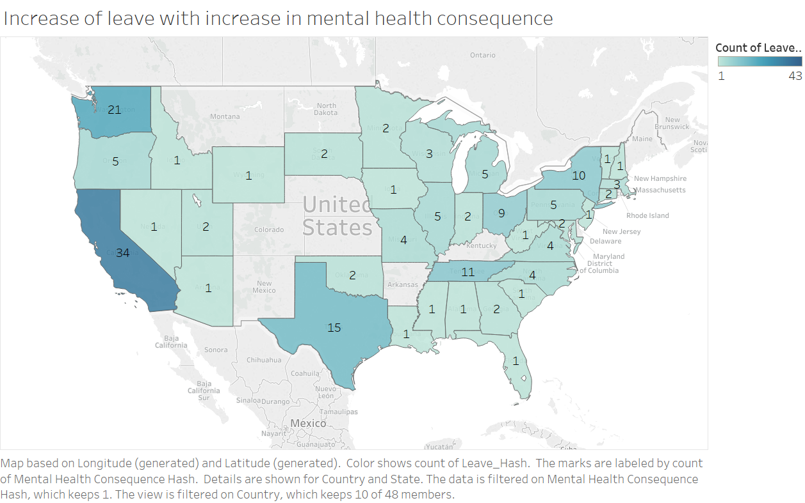

We created a choropleth using Tableau to see if states where there are perceived negative consequences for discussing mental health issues had more employees taking leaves.

The graph shows that an increase in perceived negative consequences for discussing mental health issues led to increase in employees taking leaves.

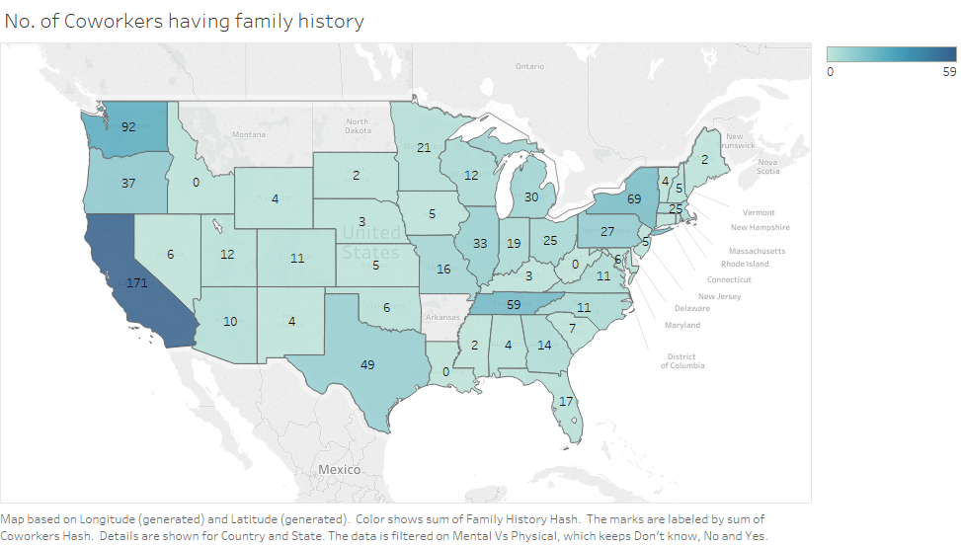

We created a choropleth using Tableau to plot the number of co-workers per state who have family history of mental health. We first converted the data to a numerical scale, where the Yes and No responses became 1 and 0, respectively.

The graph shows that the state of California had the most number of employees with family history of mental health issues.